Team info and Project proposal

Team Name: S.E.N.D.
Project Title: Marketplace Product Price Comparator App
Course: CIS 553 - 002, Fall 2022
Group Members: Nayan Patel Steve Anderau Ethan Pellegrini Dheeraj Mohanbabu
----------------------------------------------------------------------------------------------------------------------------------------
- Introduce your team:
- Group Name: S.E.N.D. (we call it SEND which came from the first letter of each group member’s name)
- Group on Canvas is here: https://canvas.umd.umich.edu/groups/178602
- Introduce each team member:
Dheeraj Mohanbabu:
I’m a Student of Master’s in Artificial intelligence with Machine Learning Concentration and I am a full time on-campus student. I have worked on a few projects related to best model selection, Identify the level of income qualification, amazon movie rating, Book recommendation system where mainly I dealt with training and predicting using the database.
Steve Anderau:
I’m a software engineering masters student with a focus in mobile and cloud computing. I work for Michigan Medicine as a data manager/full stack engineer at a research group that studies bipolar disorder. I’m a fully online student who lives in Georgia.
Ethan Pellegrini:
I’m a student in the Master’s in Artificial Intelligence Program, with a concentration in Machine Learning. Outside of my studies, I’m a Software Engineer at Stellantis on one of their Artificial Intelligence teams. My coursework is entirely remote, though I’m located in Royal Oak, MI. I will be acting as the main point of contact for the professor.
Nayan Patel:
- Student at UoM-Dearborn in the Master’s in Artificial Intelligence program with a concentration in Machine Learning.
- Technical Expert in Ford Motor Company in the Advanced Driver Assistance System project working mainly on various software development areas, ranging from architecture to software development and also in V&V.
- More than 20 years of engineering experience, with 17+ years in Embedded Systems and Software development in Automotive domain
- Accomplished engineering areas include innovation, concept design, requirements, architecture, software design and development, modeling and simulation, testing and calibration, programming and configuration, and engineering documentation
- Discuss every aspect of the team agreement in detail and describe all your decisions in the writeup.
1- methods of communication:
- Primarily UoM email; will expand to phone and Slack if necessary
- A text message group has been formed to use in case of a faster response is expected
- Team members are recommended to contact each other via phone or zoom meeting on 1:1 or 1:n basis for a quicker response
2- expected communication response times:
- Within 24 hours
3- meeting attendance:
- 3 times a week, 1 day is mandatory. Mandatory Day/Time: Thursday’s at 8pm
4- running meetings:
- Zoom meetings, Steve is the notetaker
5- meeting preparation:
- Prior shared agenda for each instance of the meeting
- Jira status update
- Any roadblock or support needed
- Any walk-ins
6- version control:
- Commit small progress frequently.
- Commit messages should reflect changes in one sentence
7- division of work:
- We will create a backlog and people will select things they would like to work on based on their skill set and interest
- PM will assign the work to a member as deemed appropriate
8- submitting assignments:
- Dheeraj/Nayan will be the submitter.
- All team members will take part in the review process.
- The plan is to submit at least a day prior to the due date
9- contingency planning:
- If a team member starts missing meetings, their tasks will be put back into the backlog and will be prioritized again during the next meeting.
- Academic dishonesty won't be tolerated and will be raised to the faculty.
- Describe the tools to be used for project development and implementation:
  - We will be using the python language to implement the code of our project.
  - For project management we will be using Jira.
  - If there is any need for computing resources, we will be using Google collab.
  - Team members are free to use other IDEs as they feel comfortable but advised to use one that has inbuilt plugins for JIRA and BitBucket.
- Project domain and proposal:
  - Intended use of the system: who and how the system will be used.
    - System will be used by consumers to shop for an item and find the lowest price. The system will present a keyword search bar where users can input free text.
  - Its overall functionality: what will the system do, how will the system help its users accomplish their tasks.
    - The system will scrape marketplace websites finding pricing of the item searched for by the user.
    - The scraper will extract key pricing (and other) information and present the user with different pricing of the same or similar item at different marketplace websites.
    - After the user inputs the keyword search for the desired marketplace item, the system will handle all calls to display price and item comparisons to the user.
  - Main components of the system: break down the system into logical or architectural components and provide the rationale for this breakdown.
    - The Project will feature three main components:
      - System will feature a user interface to allow the user to input their search.
      - The system will also utilize a python backend to use the user’s call to scrape the web for their product.
      - A user will be able to see some output information about their product visible to them on their UI.
    - Following diagram depicts the process flow of the system:
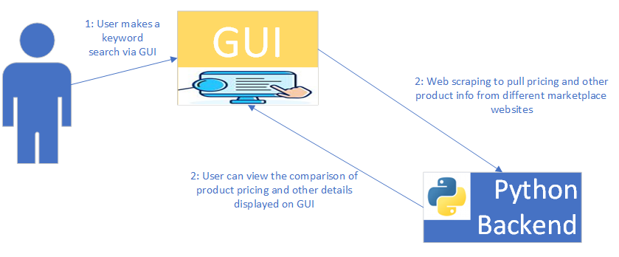
—----------------------------------------------------------------------------------------------------------------------------------------
- Checklist for this deliverable:
  - Estimated number of hours by each member:
Hours Spent on | Name of the members
 | Dheeraj Mohanbabu | Steve Anderau | Nayan Patel | Ethan Pellegrini
Week of 09/19 | 3 | 2 | 4 | 2.5
Week of 09/26 | 2.5 | 1 | 1.5 | 2
Total Hours | 5.5 | 3 | 5.5 | 4.5

  - Meeting dates since the project was kicked off:
09/22 at 8:00 PM-9:00 PM: Project kick off meeting
09/25 at 8:00 PM-9:00 PM: First deliverable discussions

